IMDB Design a DB for IMDB

1. Movie should have multiple media(Video or Image)

2. Movie can belongs to multiple Genre

3. Movie can have multiple reviews and Review can belongs to a user

4. Artist can have multiple skills

5. Artist can perform multiple role in a single film

CREATE DATABASE *imdb*;

**Movie table**

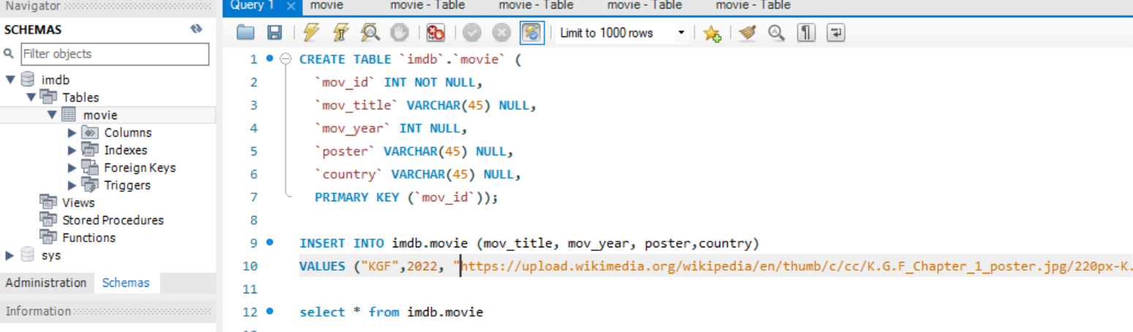

**Actor Table**

**Genres table**

**Director Table**

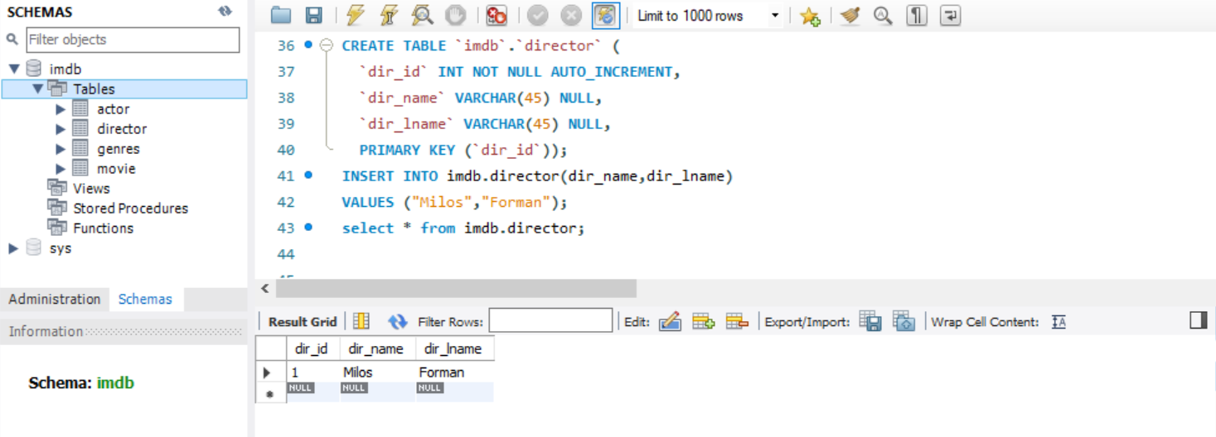

**User Table**

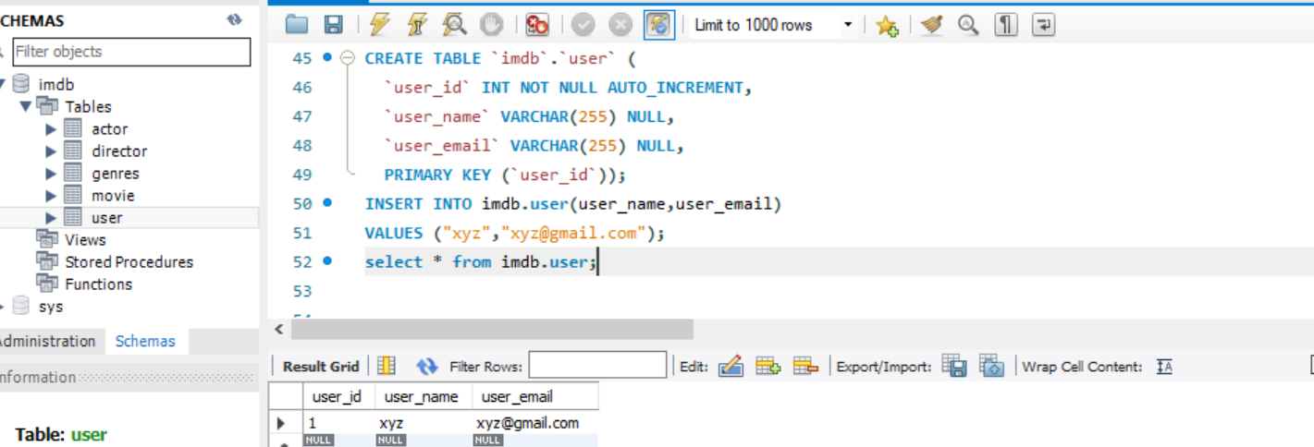

**Movie reviews 🡪joining user and movie table**

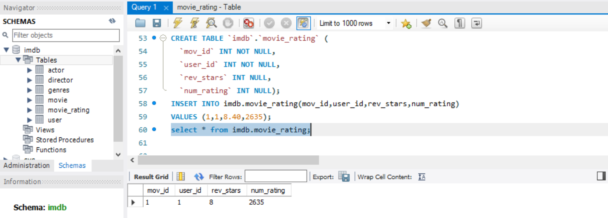

**Movie Genres**

**Movie_cast**

